From: https://davidstockmanscontracorner.com/monetary-folly-but-at-least-the-donalds-got-an-excuse/

Monetary Folly---But At Least The Donald's Got An Excuse
By David Stockman. Posted On Tuesday, November 19th, 2019
Just when you think that the Donald has plumbed the depths of monetary lunacy, he comes up with an even more ludicrous proposition. Apparently, during his session with Powell yesterday he explained to the Fed chief that in the global monetary scheme of things, it's axiomatic that the lowest rate goes to the best player---and that would be himself:
At my meeting with Jay Powell this morning, I protested fact that our Fed Rate is set too high relative to the interest rates of other competitor countries. In fact, our rates should be lower than all others (we are the U.S.). Too strong a Dollar hurting manufacturers & growth!
That's right. Already rock bottom money market rates should be lower because, well, "we are the U.S."
Folks, Donald Trump is about as mindless as they come on monetary policy. Still, even he wouldn't be advocating such rubbish if America's political economy had not been contaminated by years of Keynesian central banking and the perverted statist narrative which goes with it.
The operative words in the Donald's tweet, therefore, are not "too high", but "the rate is set". The very function of rate setting leads straight into the briar patch of endless easing and Trumpian monetary debauchery because agents of the state---politicians and apparatchiks alike---can't know the right rate, are inherently tempted to ease, and aren't needed for the job anyway.
The free market is perfectly capable of discovering the appropriate money market rate based on supply and demand conditions at any moment in time, as well as the related shape and level of the yield curve---extending from T-bills out to 50-year bonds and beyond.
Back in the day that was known as "free market price discovery" and it worked just fine.
For want of doubt, here is the trend of short-term rates in the booming decades of the 1890s and 1900s, and at a time when the U.S. did not have a central bank. So not surprisingly, on the free market the commercial paper rate (dark squares) fluctuated substantially in the 3% to 6% range during most of the 20-year period.
Likewise, the call money rate (diamonds)---which was the overnight rate on stock loans----varied even more widely, often by upwards of 1,000 basis points; and during times of money stringency or "breaks" in stock market levels, it frequently soared into double digits, thereby forcing speculators who had gotten in over their skis to be liquidated.
Here's the thing. Fluctuating free market interest rates did not break the back of prosperous capitalism---even as they periodically purged speculative excesses and the inexorable errors of business judgment.
Nor did a substantial positive yield after inflation lead to untoward effects. According to the Historical Statistics of the United States, the GDP deflator rose by just 0.83% per annum during that booming two decade interval---implying that the real rate on short term money ranged between 200 and 500 basis points.
Nevertheless, US real GDP of $320 billion (2012 $) in 1890 had grown to $730 billion by 1910---and that was despite the short but deep recession (-7% GDP) which accompanied the panic of 1907. Accordingly, the real growth rate computed to a robust 4.2% per annum during those halcyon decades.
Likewise, per capita real GDP rose from $5,090 to $7,900 (2012 $) over the 20-year period or by 2.23% per annum. And that's about as good as it has ever gotten--either before or since---and all without the helping hand of the FOMC or the artificial pegging of interest rates at ultra-low levels.
By contrast, we have had interest rate repression out the wazoo since the pre-crisis peak in Q3 2007. As we showed yesterday, money market rates were actually below the inflation rate 95% of the time during the last 140 months (i.e.negative in real terms).
Yet there was no cigar when it came to main street economic performance. Between Q3 2007 and Q3 2019, real GDP rose from $15.667 trillion (in the same 2012 $ of purchasing power) to $19.112 trillion or by just 1.67% per annum.
Similarly, real GDP per capita (2012 $) rose from $51,865 to $57,970 or be just 0.93% per annum.
In short, despite interest rate levels and volatility that defies everything the Donald and Pusillanimous Powell blabbered about at yesterday's pow wow, both aggregate real growth and per capita income gains between 1890 and 1910 were well more than double those of the past 12 years.
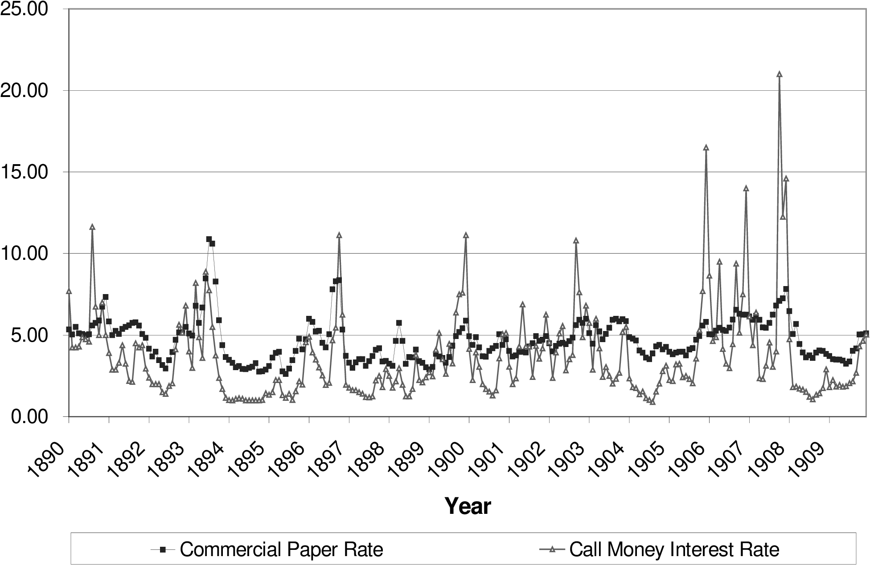
To be sure, the Donald was a leveraged real estate speculator and wanna be celebrity his entire life and did not have time to study the history of interest rates, economic growth or much of anything else.
Indeed, what in [he] apparently learned from the school of Easy Knocks from which he actually matriculated--silver spoon in mouth---was that low rates mean soaring asset prices and cheap carry costs.
Thus, between 1995 and 2017 when the Donald supposedly made his fortune after nearly going bankrupt in the early 1990s, New York real estate prices (as proxied by the condo index) rose 3.7X faster than general inflation, while the carry cost of long-term debt (dark green line) as proxied by the 10-year UST yield plunged by 70%.
The thing to do, therefore, was to be long the asset and short the debt, and at the highest possible leverage ratio. That the Donald did, apparently, and laughed all the way to the White House.
- NYC Condo Prices..........+260%
- CPI..................................+70%
- Cost Of Debt Carry.........-70%
So we'd give the Donald a kind of pass. Anyone bestowed that kind of enormous unearned windfall might well believe that prosperity comes out the end of a central bank printing press. Certainly the Donald did and does.
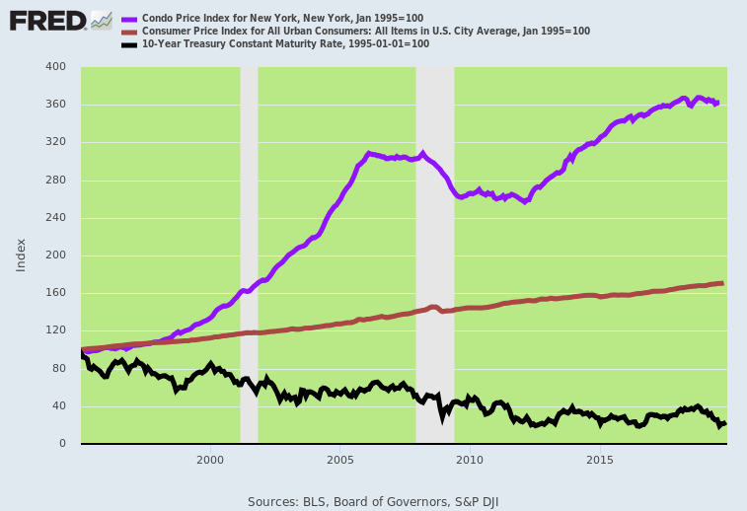
We'd be far less forgiving in the case of Powell and his merry band of money printers, however. These cats essentially believe they are masters of the financial universe---when the evidence screams out loud that they are not.
That is, they pretend to be monetary central planners without admitting the term. But how can they plan the inflation rate of a $21 trillion economy to the second decimal point or the GDP growth rate and jobs level with similar exactitude when the incoming data is inherently unreliable, imprecise and subject to endless after-the-fact revision for years to come?
In that regard, the Fed's propensity to view the entire US economy through the beer goggles of the BLS' labor market data is especially mendacious. They should know better, yet Powell keeps citing a "strong labor market" when at this stage of the longest business expansion in history he doesn't even know if the sign on the monthly jobs number is plus or minus.
David Rosenburg brought home that point in this morning's missive by citing a noisy op ed piece from a Barron's editor dated October 8, 2007 and entitled, "Why Recession is Remote". Opined veteran economy watcher, Gene Epstein,
So, what are the chances that another (recession) will strike in 2007-'08? Answer: Based on a systematic look at the indicators that appear to signal recession, chances are slim.
We pick on Gene because at the time he was citing exactly the kind of "in-coming" labor market data that is the stock and trade of the Eccles Building:
Non-farm payroll employment rose by a respectable 110,000 in September, following revised increases of 89,000 in August and 93,000 in July. That increase appears to be fast enough to match the rise in the labor force.
Well, as it happened, not exactly. The three month-gain of nearly 300,000 jobs cited by Epstein at the time got washed away entirely after 5-years worth of revisions, which are ultimately based on payroll tax records of real world employers, not the BLS's trend-following models.
To wit, the data now shows a miniscule 26,000 job gain over this three-month, eve-of-recession period, including a loss of -33,000 jobs in July 2007 and -23,000 in August.
In fact, old Gene got too cheeky by half when he noted that the then reported +89,000 for August had been originally reported as a loss and had given rise to erroneous recession warnings:
Revision was the watchword in the September jobs report. For August, the Bureau of Labor Statistics reported a statistically insignificant decline of 4,000 in non-farm payrolls, prompting the New York Times to run the headline, "Unexpected Loss of Jobs Raises Risk of Recession." Not for the first time, and probably not for the last, the loss of 4,000 has now been revised to a gain of 89,000. Imagine the corrected headline: "Unexpected Upward Revision in Jobs Raises Risk of No Recession."
He got the "revision" part right. The negative that had become a positive ended up an even worse negative (-23,000).
Still, our real quibble is not with the virtual certainty that BLS jobs counts get revised sharply downwards at the end of expansion cycles, but the fact that the Fed heads pay any attention at all to the raw monthly jobs counts. The latter are a badly lagging indicator that are actually the last to know.
To wit, the real tell is hours worked and not the NFP head counts because:
- Overtime gets cut first
- Then scheduled regular hours
- Then hiring slowdowns and moratoriums
- Finally layoffs and job cuts
In any event, the October Jobs report showed that the hours index has been virtually flatling since March, and that's not "strong" anyway you slice it.
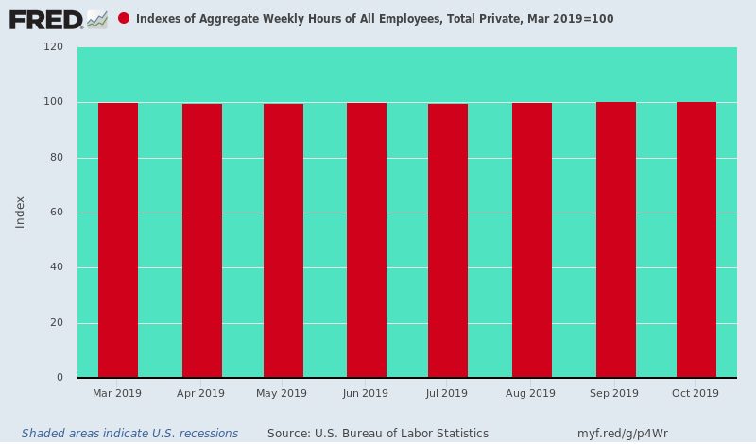
Even more to the point, the lapse of the main street economy into recession does not occur in lockstep across one and all sectors and jobs categories. To the contrary, it starts in the more cyclical and volatile goods sector and cascades out from there to---
- Support industries such as warehousing and transportation, eventually infecting the entire rhythm of earnings and spending.
- The goods-producing sector has already downshifted from 4% on a year-over-year growth during the 2018 spring/summer sugar high to essentially zero during the last two months.
- The goods-producing sectors---manufacturing, construction and energy/mining---are the high pay rate sectors of the US economy
- The annualized equivalent of weekly earnings in the mining/energy, construction and manufacturing sectors were $82,000, $63,100 and $58,700, respectively during August.
- By contrast, retail jobs generated annual equivalent wages of $31,600, while education and health services and leisure and hospitality posted annualized rates of $47,300 and $22,300, respectively.
So, inherently, the US economy is not "strong" when the goods-producing sector is cliff-diving as shown below.

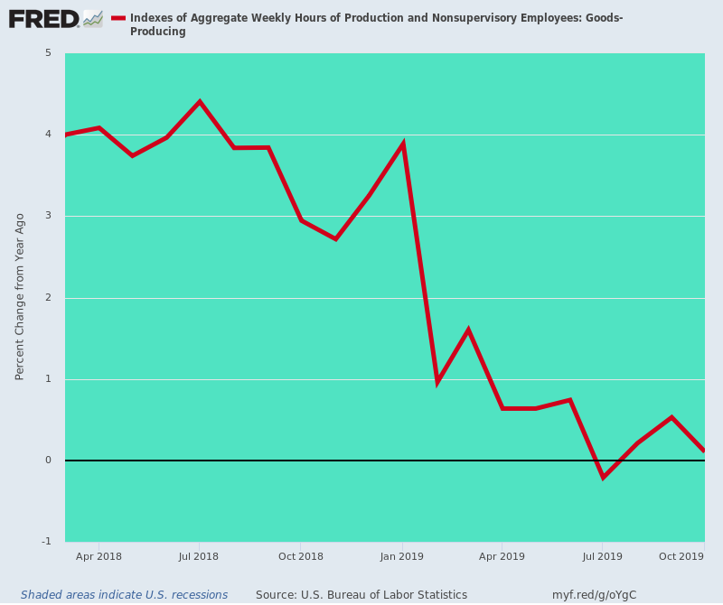
Likewise, there is no evidence of "strong" when it comes to wage gains after inflation. Average weekly wage growth has decelerated sharply in recent months owing to the adverse mix shift in total employment. As shown be the purple line, year-over-year wage gains posted at 3.64% last October, but had diminished to just 2.74% during October 2019.
At the same time, the inflation rate has crept slightly higher---with the trimmed-mean CPI posting at 2.24% last year and 2.36% in October 2019.
Accordingly, the real wage gain of 1.40% recorded during October 2018 has steadily narrowed, shrinking to just 0.35% in the month just ended. Even the Donald might well be hard-pressed to explain how the squeeze on real wages depicted in the chart below relates to the concept of "strong".

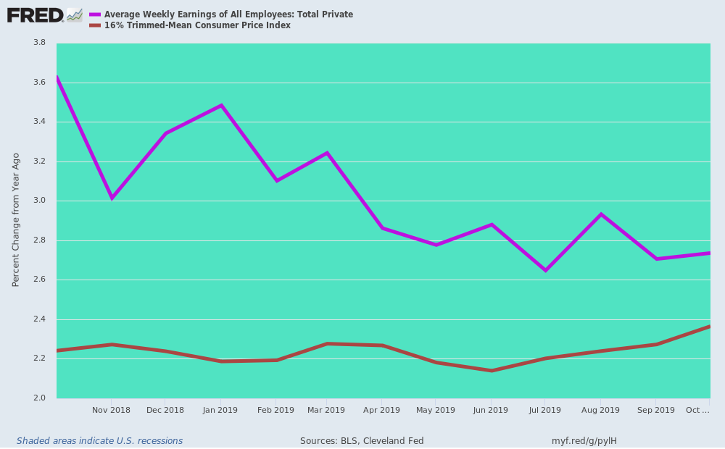
The same story holds for business CapEx. After last summer's tax-cut induced sugar high, nonresidential investment spending has been heading down for the count, posting at negative 2.6% annual rate in Q3 compared to +8.1% in Q1 2018.
The point is, there is simply no pump-priming effect from the Fed's ultra low interest rates, and the corporate rate cut cherry on top. So that's not strong, either.

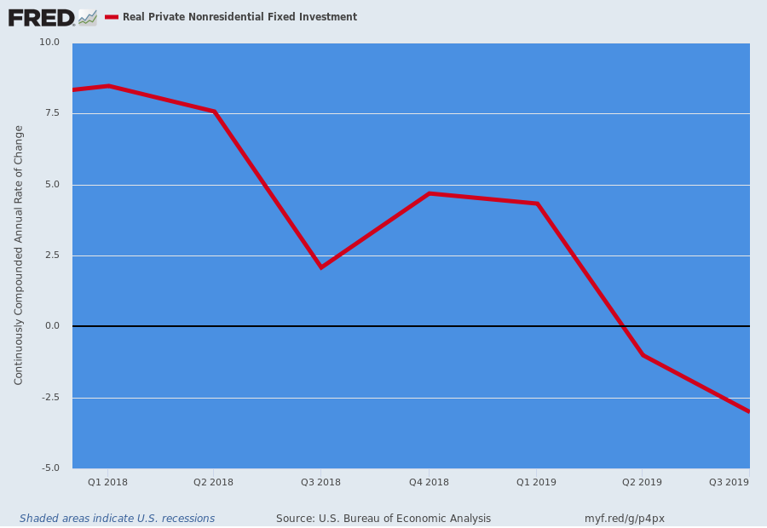
At the end of the day, the Donald probably doesn't know better when he demands that the Fed "set rates" at a level he mistakenly believes will stimulate growth and prosperity---even MAGA.
But the Keynesian apparatchiks who run the central bank printing press are really the dangerous actors in the drama. Notwithstanding massive balance sheet expansion, relentless financial repression and ceaseless falsification of financial asset prices, they have presided over a main street business cycle that barely got off the ground, and is now heading down for the count.
In fact, there has been no recovery at all in the core main street economy:
- Electric power output is still down 5.4% from the 2007 pre-crisis peak;
- Manufacturing output is down 2% after 10 years of so-called recovery
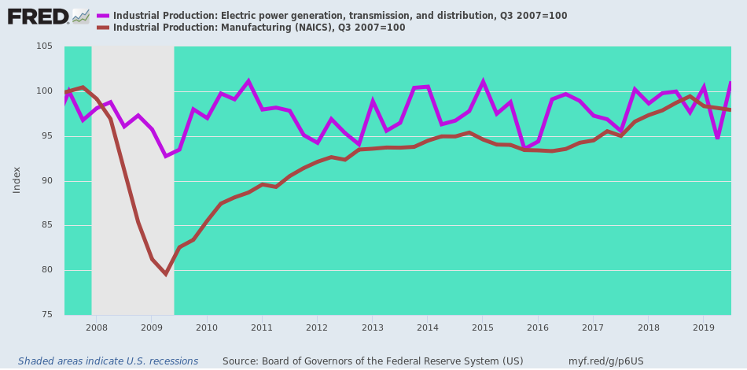
What they have accomplished is merely to bury the main street economy deeper in debt.
- Total debt is up by nearly $21 trillion from the pre-crisis peak in Q4 2007 to a staggering $73.4 trillion at the end of Q2 2019or or by 40%;
- During the same 12-year period, nominal GDP increased by only $6.8 trillion, meaning it took $3 of incremental debt to generate just $1 of additional GDP;
- At this rate there would be $100 trillion of combined public and private debt by 2029 on less than $30 trillion of GDP.
Total U.S. Public And Private Debt
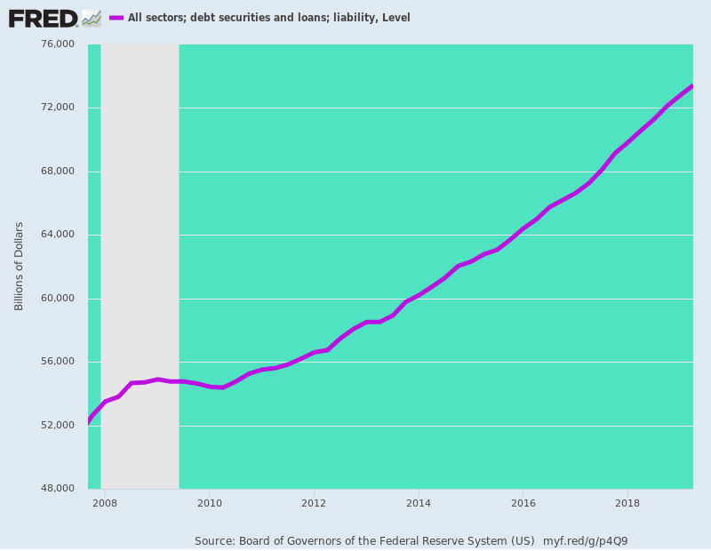
So we hope that there are less White House/Fed pow wows in the months ahead and more of the Donald's street-brawling fisticuffs.
Someone has to stop the Keynesian central bankers before they destroy capitalist prosperity entirely. And for better or worse, the Donald is the only hope left.

